Experiment-1

Basic functions of R

**Aim :-** To perform some basic functions of R **Date:-** 14/09/2024

# Codes :-

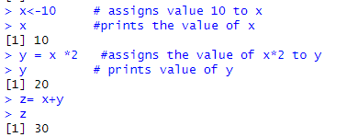

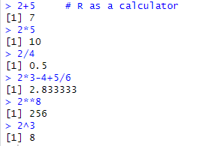

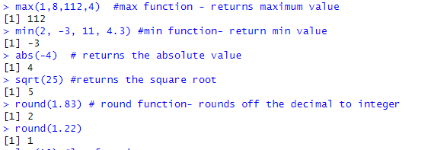

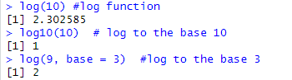

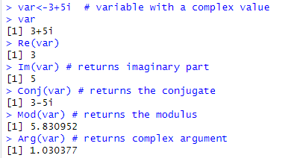

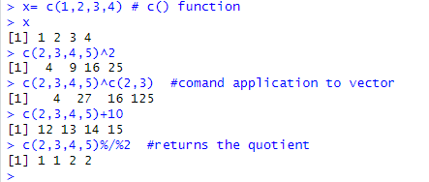

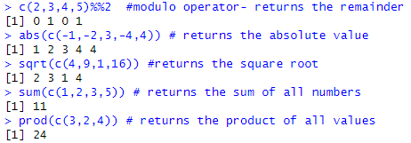

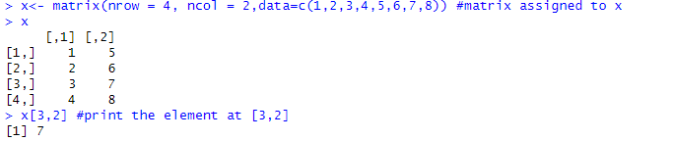

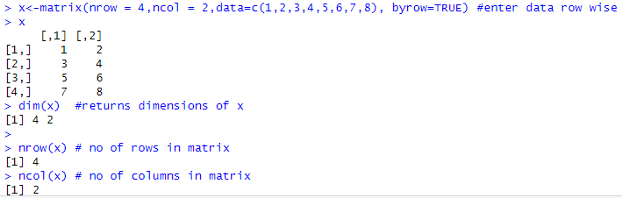

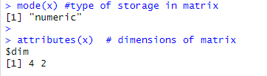

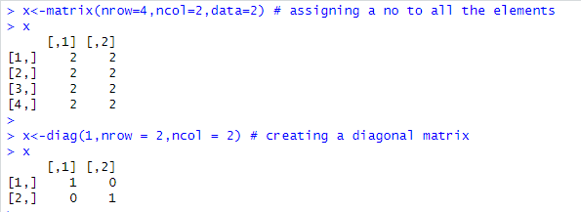

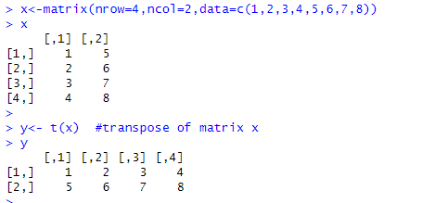

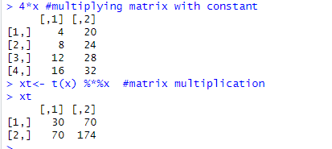

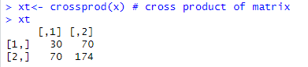

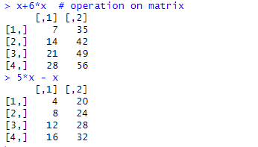

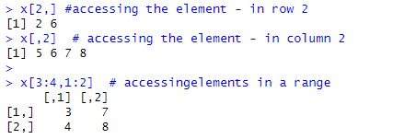

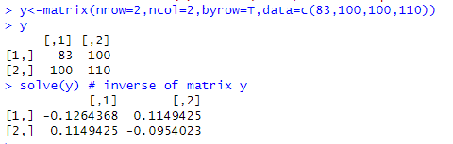

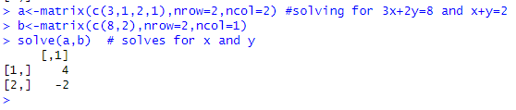

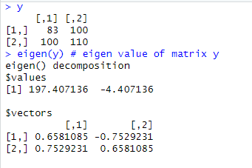

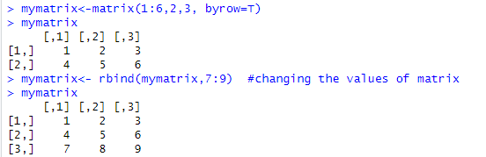

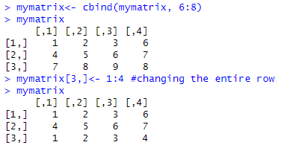

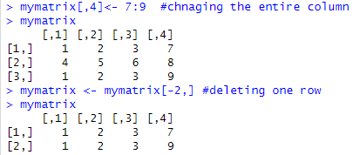

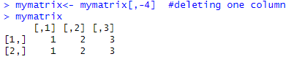

**Experiment-2**

Import CSV file data in R

**Aim :-** To import data of csv files and perform functions **Date:-** 21/09/2024

# Codes :-

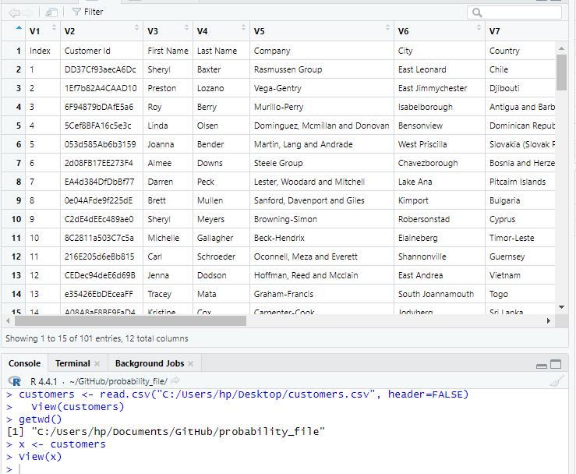

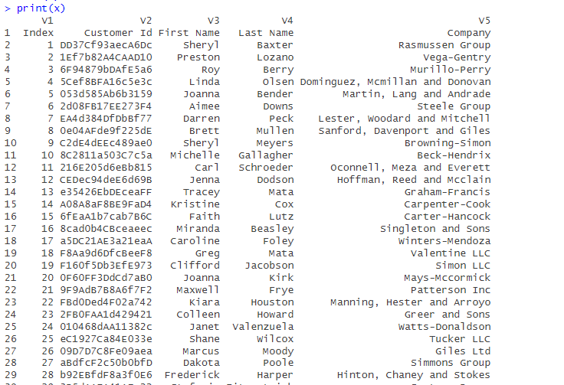

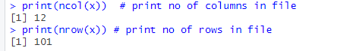

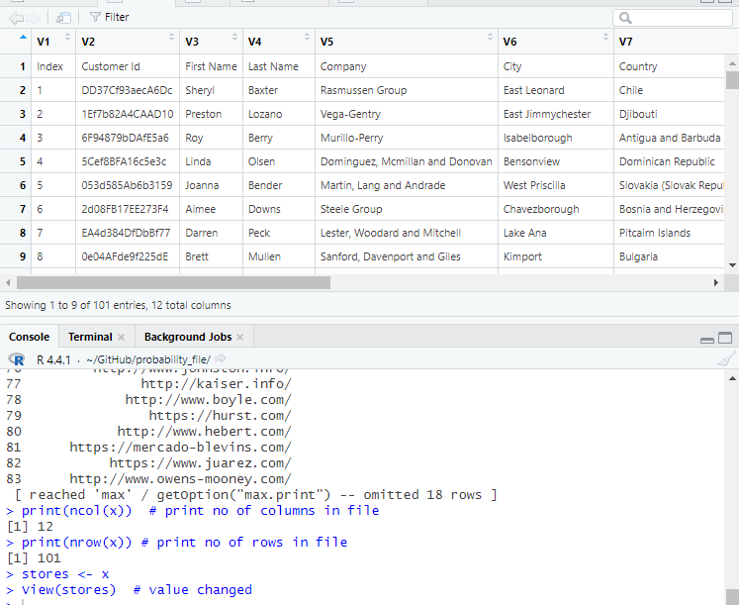

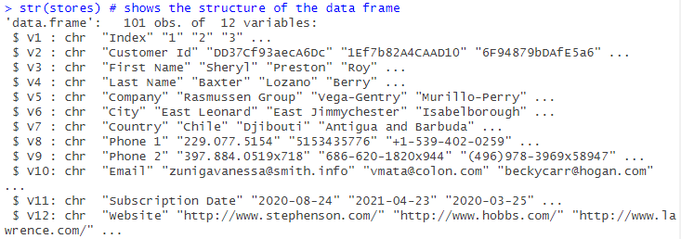

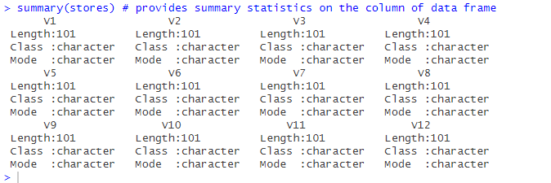

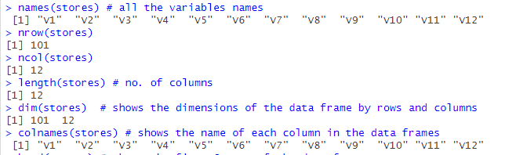

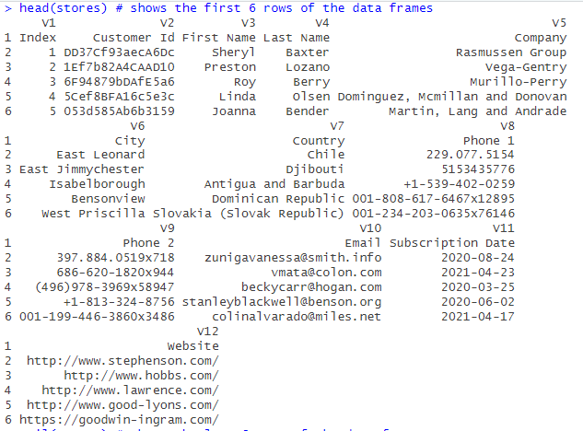

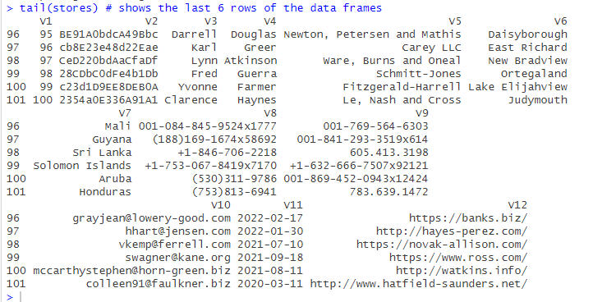

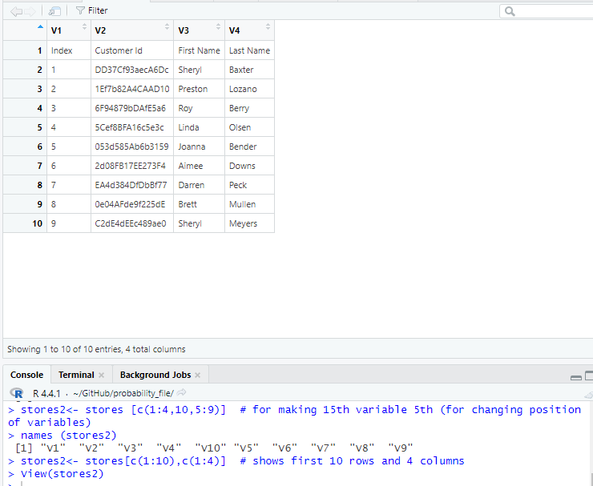

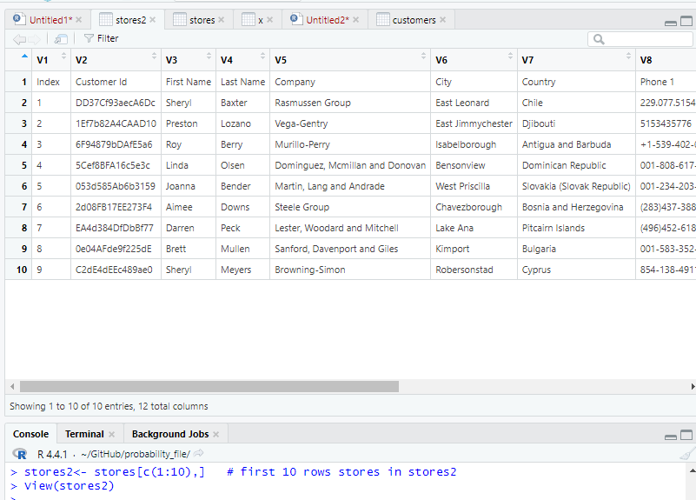

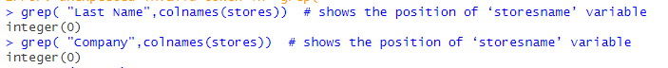

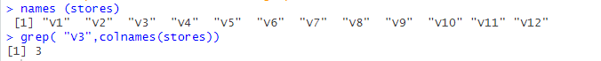

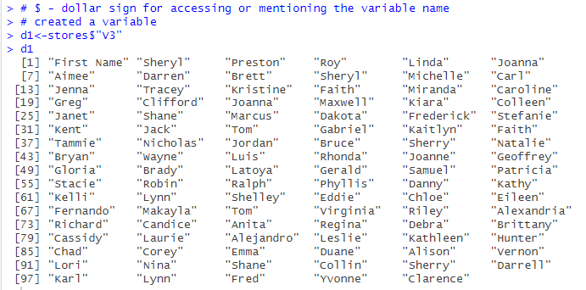

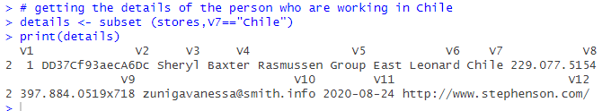

Experiment-3

**Aim :-** To calculate descriptive statistics like mean, median and standard deviation

**Date:-** 28/09/2024

# Codes :-

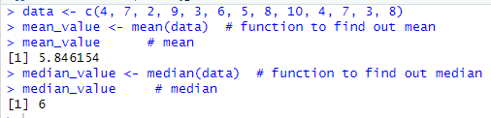

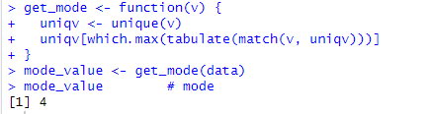

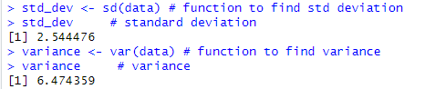

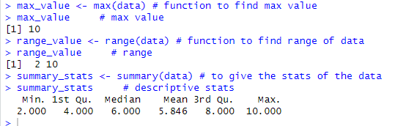

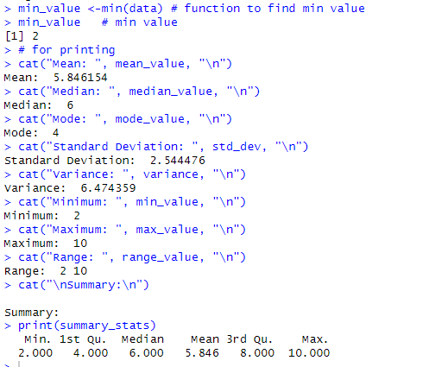

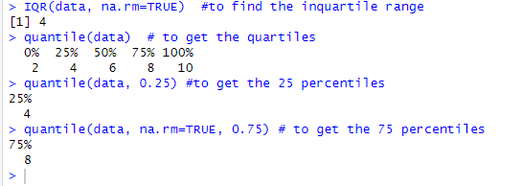

Q1.Twenty students, graduates and undergraduates, were enrolled in a statistics course. Their ages were 18,19,19,19,19,20,20,20,20,20,21,21,21,21,22,23,24,27,30,36.

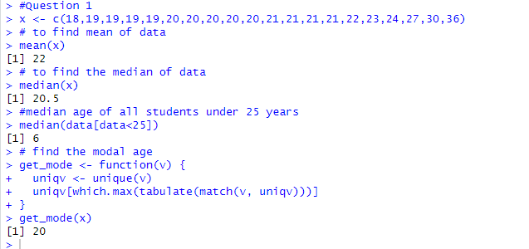

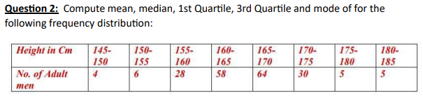

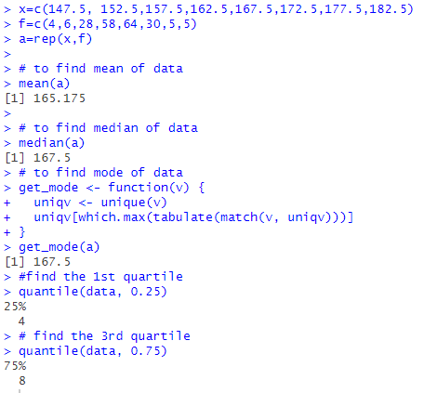

Experiment-4

Graphical Representation

**Aim :-** To visualize the data using tabulation and graphical representation such as histograms, boxplots, scatter plots and bar charts.

**Date:-** 05/10/2024

# Codes :-

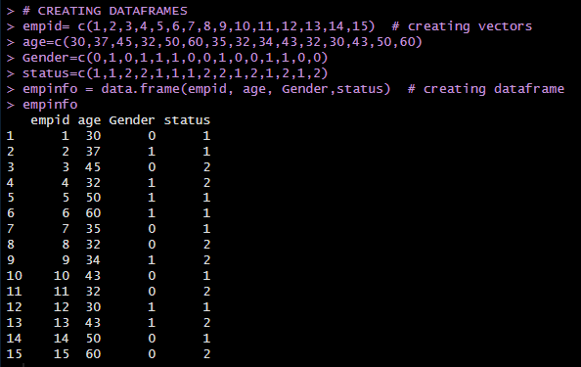

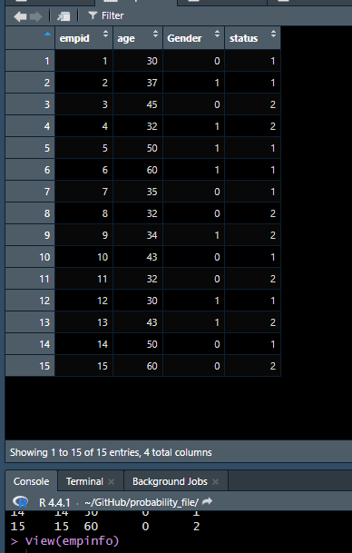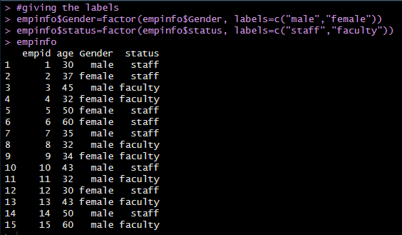

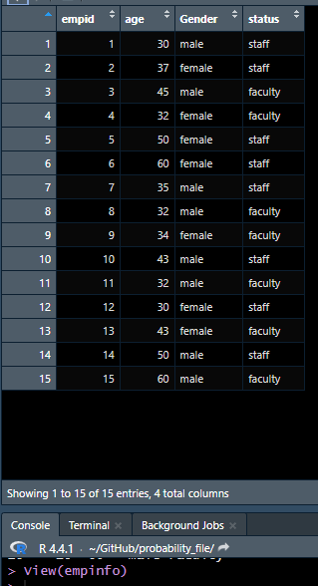

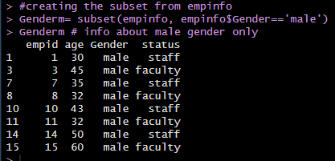

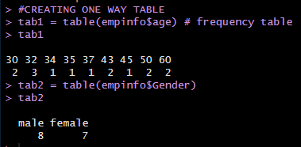 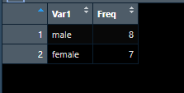

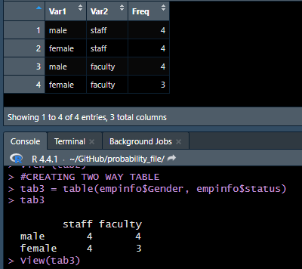

# 

# 

# 









Q1. Plot a graph of status





Q2. Boxplot of age and gender.





Q3. Plot(x,x*2,col='red',type='l')





Q4. Plot(x,log(x),col='orange',type='s')





Q5. temperatures <- c(67 ,72 ,74 ,62 ,76 ,66 ,65 ,59 ,61 ,69 ). Plot histogram





Experiment-5

**Aim :-** Simulate random outcomes and calculate probabilities for the case of coin flips and card draws.

**Date:-** 05/10/2024

# Codes :-

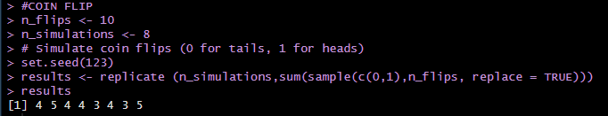

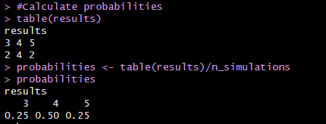

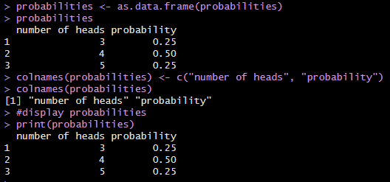

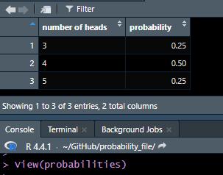

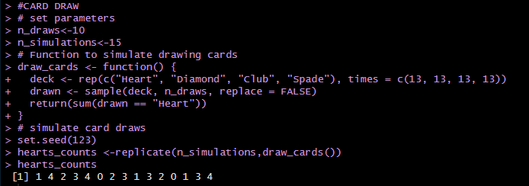

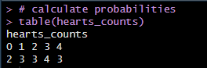

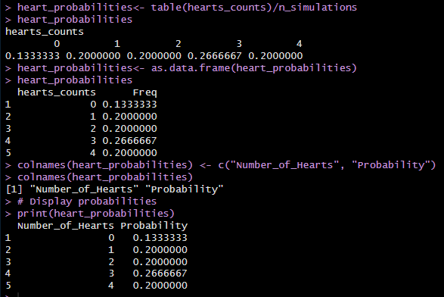

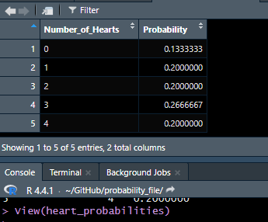

Experiment-7

**Aim :-** Simulate experimental probabilities and compare it with theoretical probabilities

**Date:-** 02/11/2024

# Codes :-

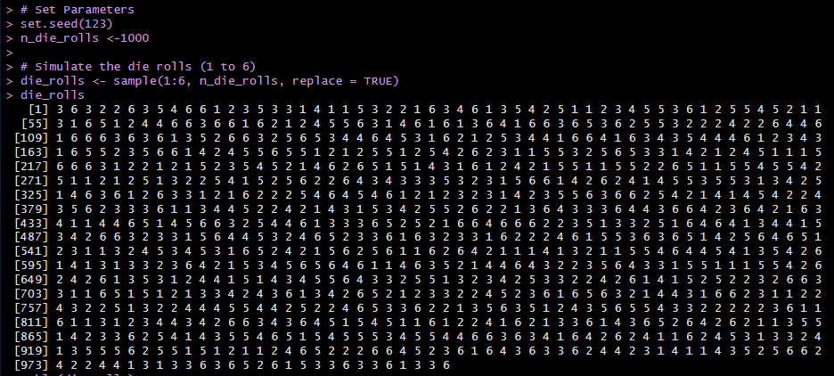

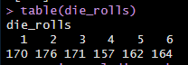

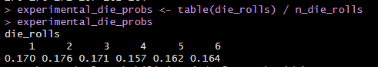

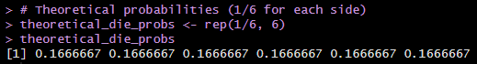

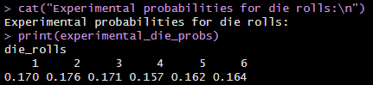

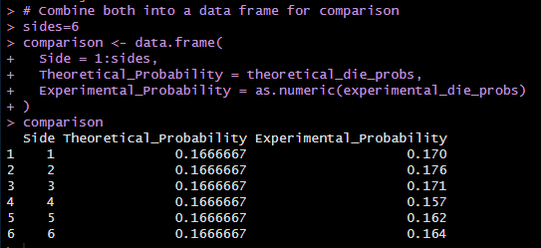

View(comparison)

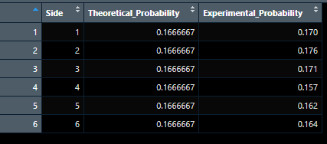

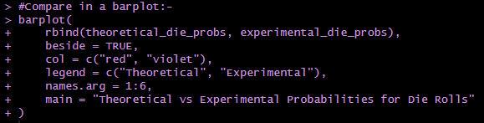



Q1. Run the code to simulate experimental probabilities of Drawing a Card from Deck and compare it with theoretical probabilities. Also compare in barplot.

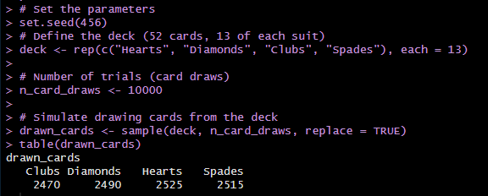

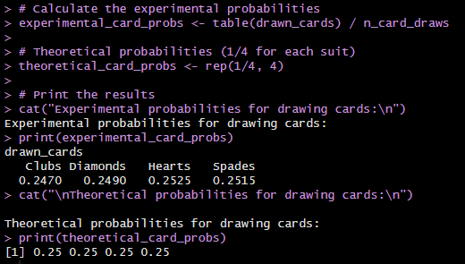

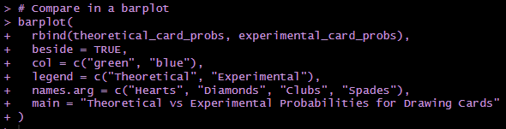



Q2. After setting seed to 1234 , Run the code to simulate experimental probabilities of Coin Flip and compare it with theoretical probabilities.

a). Also compare in barplot.

b). Compare in line graph.

c). Combine both into a data frame for comparison and View table.

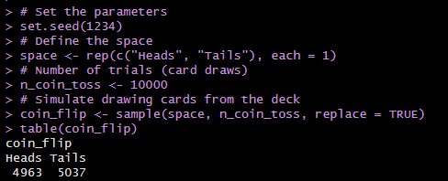

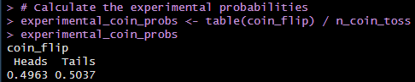

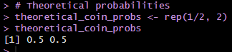

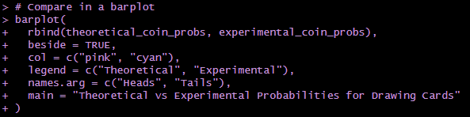







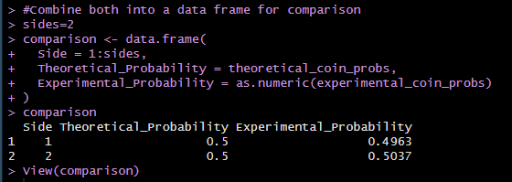

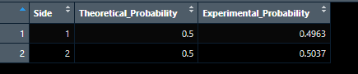

Experiment-6

**Aim :-** Calculate expected value and variance in the context of single random variable.

**Date:-** 28/10/2024

# Codes :-

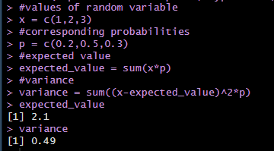

Example 2 - A class XII has 20 students whose marks (out of 30) are 14, 17, 25, 14, 21, 17, 17, 19, 18, 26, 18, 17, 17, 26, 19, 21, 21, 25, 14 and 19 years. If random variable X denotes the marks of a selected student given that the probability of each student to be selected is equally likely.

a) Prepare the probability distribution of the random variable X.

b) Find mean, variance and standard deviation of X.

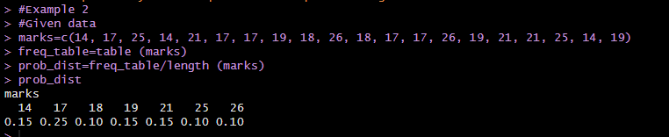

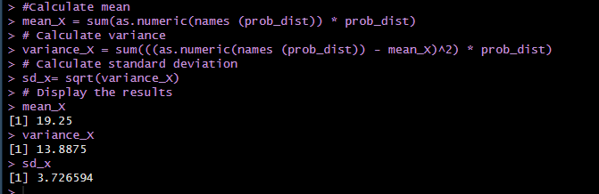

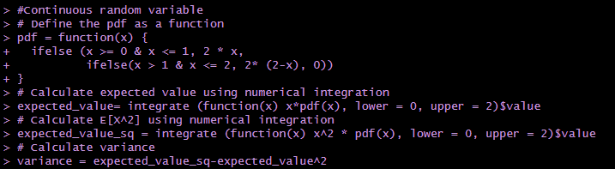

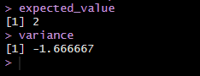

Ques1. Consider a discrete random variable 𝑋 with the following possible values and their corresponding probabilities: Values: 0, 3, 5, 10 ; Probabilities: 0.2, 0.1, 0.1, 0.6. Calculate the expected value [𝑋] and variance [𝑋] of the random variable.

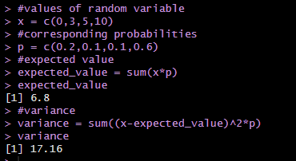

Ques 2. Consider 𝑋 as a random variable representing the outcome of rolling a fair six-sided die. Calculate the expected value and variance of the random variable

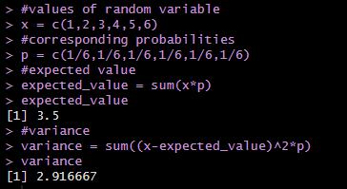

Ques 3. Consider a continuous random variable 𝑋 with probability density function:

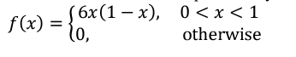

Find expected value and variance of 𝑋.

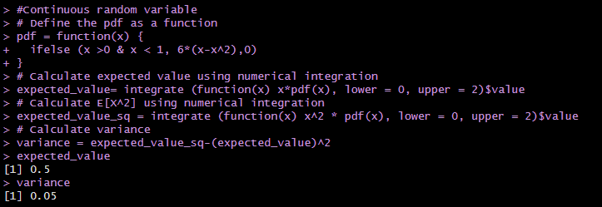

Experiment-8

**Aim :-** Generate and plot probabilities for events in discrete and continuous distributions (Binomial, Poisson, Geometric, and Normal).

**Date:-** 09/11/2024

# Codes :-

**Binomial distribution**

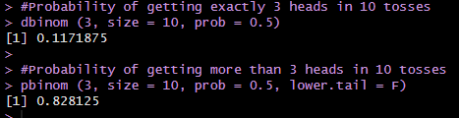

Example 1:

Calculate the probability of obtaining heads in an experiment of flipping a fair coin 10 times. Also, create a bar plot to visualize the probabilities for each possible outcome (number of heads).

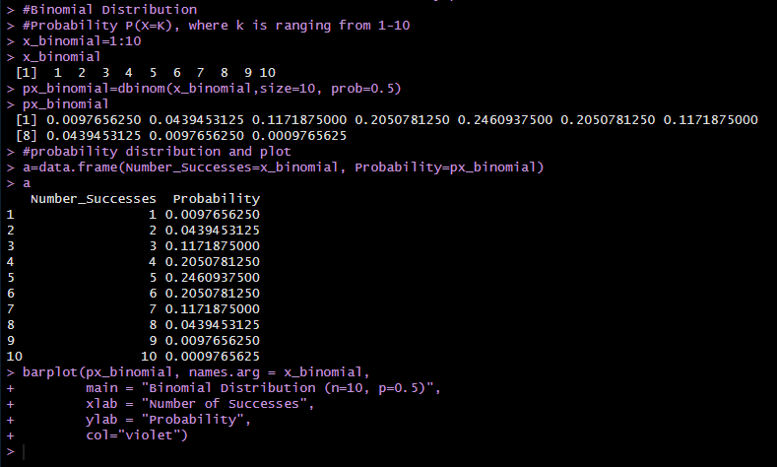



Example 2:

A factory produces widgets, and the probability that a widget is defective is 0.05. If a quality control inspector randomly selects 5 widgets, make a cumulative probability table.

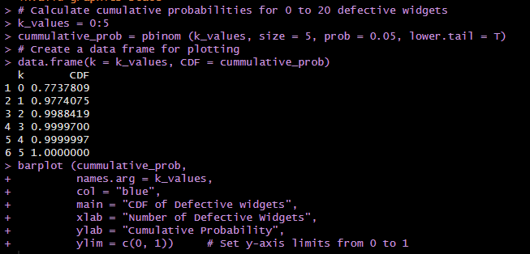



**Poisson distribution**

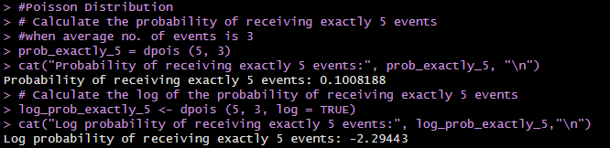

Example 1:

A bookstore sells an average of 4 books per hour. What is the probability that the bookstore sells exactly 2 books in a given hour? Additionally, visualize the probability mass function (PMF) of the Poisson distribution for the number of books sold from 0 to 10 in one hour.

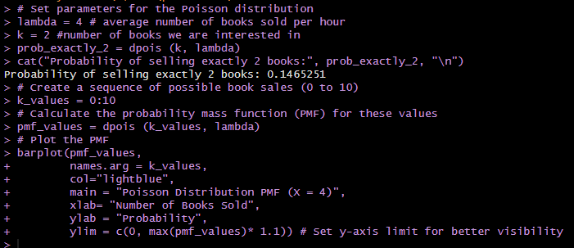



Example 2:

A data analyst is studying various events modeled by the Poisson distribution. They want visualize the probability mass functions for four different scenarios, each with a different average rate of occurrence.

* For the first scenario, the average number of hits on a website is 2 hits per hour.
* The second scenario involves calls to a mobile phone, averaging 3 calls per hour.
* The third scenario focuses on job submissions received, with an average of 4 submissions per hour.
* Lastly, the fourth scenario tracks messages sent to a server, averaging 6 messages per hour.

Create a 2x2 grid of plots to display the probability mass functions (PMF) for these four Poisson distributions, with the x-axis representing the number of occurrences and the y-axis representing the probability of those occurrences.

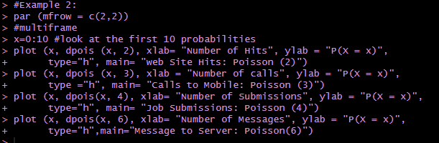



**Geometric distribution**

Example 1

In a scenario where the probability of success in a Bernoulli trial is 0.2, what is:

1. The probability of experiencing exactly 3 failures before achieving the first success?

2. The cumulative probability of experiencing at most 3 failures before the first success?

3. Additionally, visualize the probability mass function (PMF) of the geometric distribution for the first 10 trials.

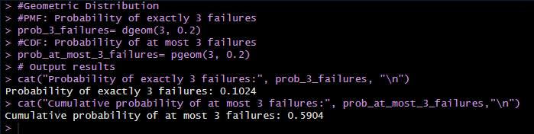

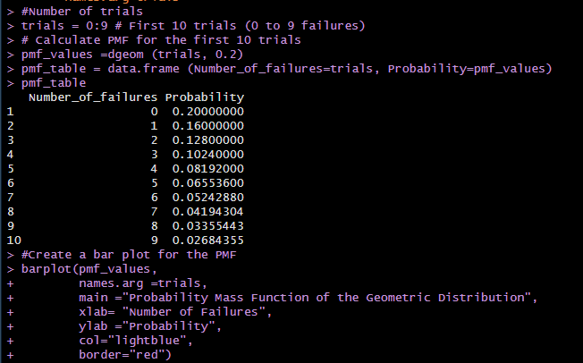



**Normal Distribution**

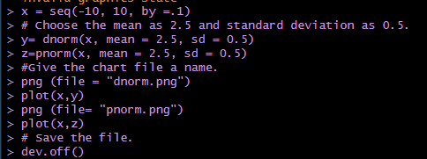

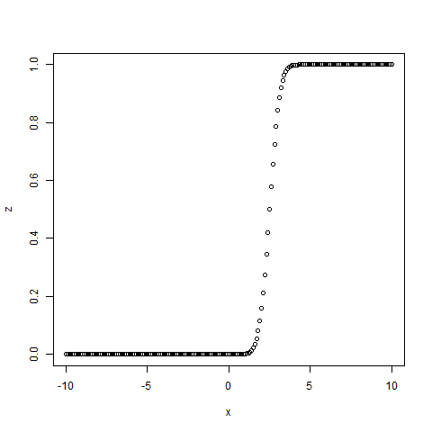 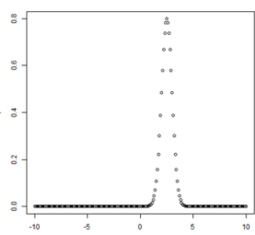

Example 1

The weekly wages of 1000 workmen are normally distributed around a mean of Rs. 70 with S.D of Rs 5. Estimate the number of workers whose weekly wages will be

(i) Between Rs 69 and Rs 72

(ii) Less than Rs 69

(iii) More than Rs 72

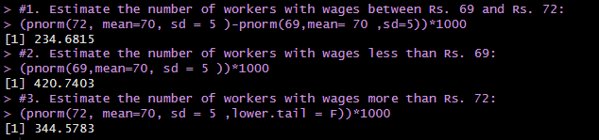

Example 2.

(a) Draw a normal distribution with a mean=60 and a standard deviation=15

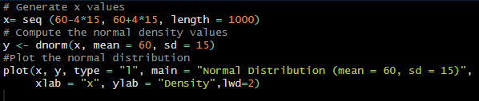



(b) Shade the top 20% of the area under the normal density curve

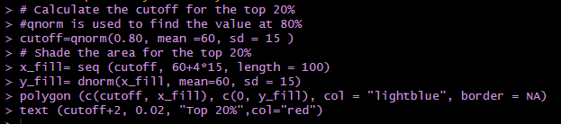



(c) Shade middle 68% of the area under the normal density curve

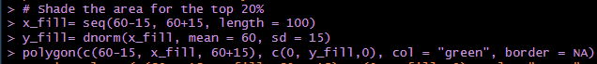

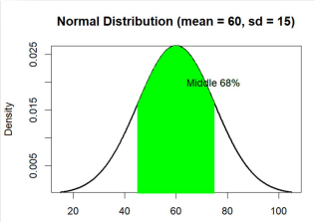

Ques 1. A factory produces light bulbs, and the probability that a light bulb is defective is 0.1. If a quality control inspector randomly selects 15 light bulbs, what is the probability that 3 or fewer of them are defective? Also cdf table

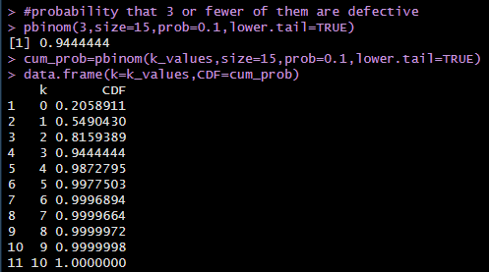.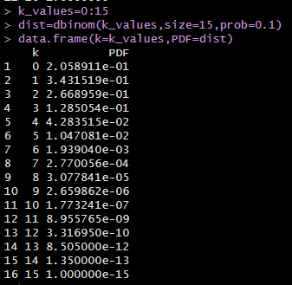

Ques 2. Consider a computer system with Poisson job-arrival stream at an average of 2 per minute. Determine the probability that in any one-minute interval there will be (i) 0 jobs (ii) Exactly 3 jobs (iii) at most 3 arrivals (iv) between 2 to 4 arrivals

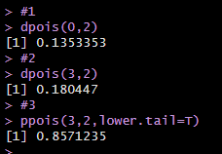

Ques 3. A new online game has a 60% success rate for players achieving a high score on their first attempt.

(i) Calculate the probability that a player will succeed in achieving their first high score after exactly 4 unsuccessful attempts.

(ii) If the game allows players to keep trying until they succeed, what is the expected number of attempts a player will make before achieving their first high score.

(iii) Additionally, what is the probability that a player will succeed within the first 6 attempts?

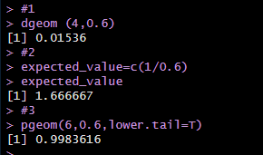

Ques 4.

In a test on 2000 Electric bulbs ,it was found that the life of particular make, was normally distributed with an average life of 2040 hours and S.D of 60 hours. Estimate the number of bulbs likely to burn for:

(i) More than 2150 hours

(ii) Less than 1950 hours

(iii) More than 1920 hours but less than 2160 hours

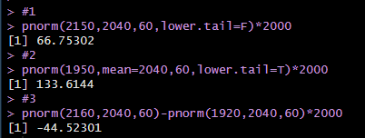

Experiment-9

**Aim :-** Applying the t-test for independent and dependent samples.

**Date:-** 16/11/2024

# Codes :-

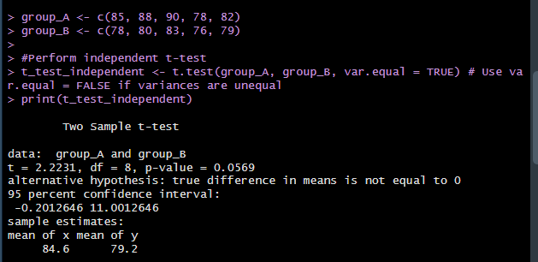

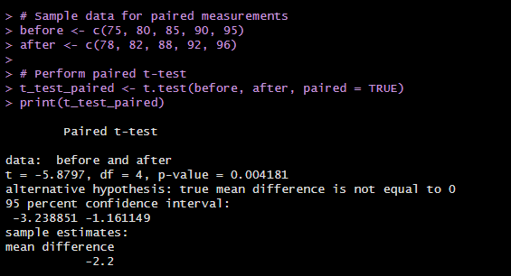

Q1. Suppose you are testing the effectiveness of two teaching methods on student performance. You have two groups of students, each taught with a different method. Test whether there is a significant difference between the two groups' average scores.

Method1: 78, 82, 84, 88, 90, 85, 87, 89, 90, 80

Method2: 75, 79, 81, 83, 78, 80, 82, 84, 85, 77

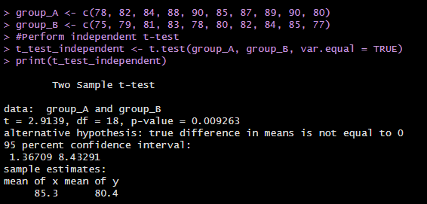

Q2. You want to check the effectiveness of a new learning app by measuring the same students' scores before and after using it. Test if there is a significant improvement in scores after using the app.

Before: 65, 68, 70, 72, 66, 75, 67, 69, 71, 68

After: 70, 72, 75, 78, 70, 80, 73, 75, 78, 74

